**NITTE MEENAKSHI INSTITUTE OF TECHNOLOGY**

(AN AUTONOMOUS INSTITUTION, AFFILIATED TO VISVESVARAYA TECHNOLOGICAL UNIVERSITY, BELGAUM, APPROVED BY AICTE & GOVT.OF KARNATAKA

**LA-2 REPORT**

on

**JIRA**

*Submitted in partial fulfilment of the requirement for the award of Degree of*

*Bachelor of Engineering*

*in*

*Computer Science and Engineering*

*Submitted by:*

|  |  |
| --- | --- |
| V VENKATA SREE HARSHA  VASUDEVA S | 1NT18CS181  1NT18CS183 |
|  |  |
|  |  |

Under the Guidance of

MRS JAGDEVI N KALSHETTY

Assistant Professor, Dept. of CS&E, NMIT



Department of Computer Science and Engineering

**(Accredited by NBA Tier-1)**

2021-22

**NITTE MEENAKSHI INSTITUTE OF TECHNOLOGY**

(AN AUTONOMOUS INSTITUTION, AFFILIATED TO VISVESVARAYA TECHNOLOGICAL UNIVERSITY, BELGAUM

, APPROVED BY AICTE & GOVT.OF KARNATAKA)

Department of Computer Science and Engineering

**(Accredited by NBA Tier-1)**

**CERTIFICATE**

This is to certify that the Phase 1 Report on **JIRA** is an authentic work carried out by V Venkata Sree Harsha **(**1NT18CS181**),** Vasudeva S (1NT18CS183**)** bonafide students of **Nitte Meenakshi Institute of Technology**, Bangalore in partial fulfilment for the award of the degree of ***Bachelor of Engineering*** in COMPUTER SCIENCE AND ENGINEERING of Visvesvaraya Technological University, Belagavi during the academic year ***2021-2022.*** It is certified that all corrections and suggestions indicated during the internal assessment has been incorporated in the report.

|  |  |  |  |  |  |
| --- | --- | --- | --- | --- | --- |
| **Internal Guide** | | **Signature of the HOD** | | **Signature of Principal** | |
|  | |  | |  | |
| Mrs. Jagdevi N Kalshetty  Assistant Professor, Dept. CSE,  NMIT Bangalore | | Dr. SarojaDevi  Professor, Head, Dept. CSE, NMIT Bangalore | | Dr. H. C. Nagaraj  Principal,  NMIT, Bangalore | |
| **Signature of Examiners** | | | |
|  | |  | |
|  | |  | |
|  | |  | |

**DECLARATION**

We are hereby declare that

(i) The project work is our original work

(ii) This Project work has not been submitted for the award of any degree or examination at any other university/College/Institute.

(iii) This Project Work does not contain other persons’ data, pictures, graphs or other information, unless specifically acknowledged as being sourced from other persons.

(iv) This Project Work does not contain other persons’ writing, unless specifically acknowledged as being sourced from other researchers. Where other written sources have been quoted, then:

a) their words have been re-written but the general information attributed to them has been referenced;

b) where their exact words have been used, their writing has been placed inside quotation marks, and referenced.

(v) This Project Work does not contain text, graphics or tables copied and pasted from the Internet, unless specifically acknowledged, and the source being detailed in the thesis and in the References sections.

|  |  |  |
| --- | --- | --- |
| **NAME** | **USN** | **Signature** |
| V VENKATA SREE HARSHA | 1NT18CS181 |  |
| VASUDEVA S | 1NT18CS183 |  |

Date: 06/01/2022

**ACKNOWLEDGEMENT**

The satisfaction and euphoria that accompany the successful completion of any task would be incomplete without the mention of the people who made it possible, whose constant guidance and encouragement crowned our effort with success. I express my sincere gratitude to our Principal **Dr. H. C. Nagaraj**, Nitte Meenakshi Institute of Technology for providing facilities.

We wish to thank our HoD**, Dr. Sarojadevi** for the excellent environment created to further educational growth in our college. We also thank him for the invaluable guidance provided which has helped in the creation of a better project.

I hereby like to thank our ***Mrs. Jagdevi N Kalshetty , Assistant Professor***, Department of Computer Science & Engineering on **her** periodic inspection, time to time evaluation of the project and help to bring the project to the present form.

Thanks to our Departmental Project coordinators. We also thank all our friends, teaching and non-teaching staff at NMIT, Bangalore, for all the direct and indirect help provided in the completion of the project.

|  |  |  |
| --- | --- | --- |
| **NAME** | **USN** | **Signature** |
| V VENKATA SREE HARSHA | 1NT18CS181 |  |
| VASUDEV S | 1NT18CS183 | VASUDEV S |

Date: 06/01/2022

**Introduction**

JIRA is an Incident Management Tool used for Project Management, Bug Tracking, Issue Tracking and Workflow. JIRA is based on the following three concepts – Project, Issue and Workflow.

Following are some of the most significant uses of JIRA.

1. JIRA is used in Bugs, Issues and Change Request Tracking.
2. JIRA can be used in Helpdesk, Support and Customer Services to create tickets and track the resolution and status of the created tickets.
3. JIRA is useful in Project Management, Task Tracking and Requirement Management.
4. JIRA is very useful in Workflow and Process management.

**JIRA Infographics:**

* Boards
* Business Project Template
* Task Details
* Notifications
* Power Search
* Reports
* Scale with Team Growth
* Add-Ins
* Multilingual
* Mobile App

**JIRA-Project:**

This JIRA-Project will be very helpful for many companies to process their projects. Not only companies even in the colleges it is very useful. It is useful in the Software Development Project. And also regarding the marketing it would be useful in the Marketing Project. Migration of the project which was made in the JIRA is supported. Manage Issues and Tickets. And this JIRA highly useful in the CI/CD (i.e) Continuous Integration and Continuous Development. And also it is possible to track the project.

**Project Management & Issues:**

* Deploy & Maintain
* Create Project/Tasks
* Develop & Test
* Add Members and Assign Task
* Task of a story
* Sub-task of a story
* Helpdesk Ticket
* Leave Request

**JIRA Workflow:**

In JIRA, workflow is used to track the lifecycle of an Issue. Workflow is a record of statuses and transitions of an issue during its lifecycle. A status represents the stage of an issue at a particular point.

An issue can be in only one status at a given point of time like Opened, To Do, Done, Closed, Assigned, etc. A transition is a link between two statuses when an issue moves from one status to another.

For an issue to move between two statuses, a transition must exist. In a simple way, a transition is some kind of work done on the issue, while status is the impact of work on that issue.

* Open Issue
* In Progress Issue
* Resolved Issue
* Reopened Issue / Closed Issue

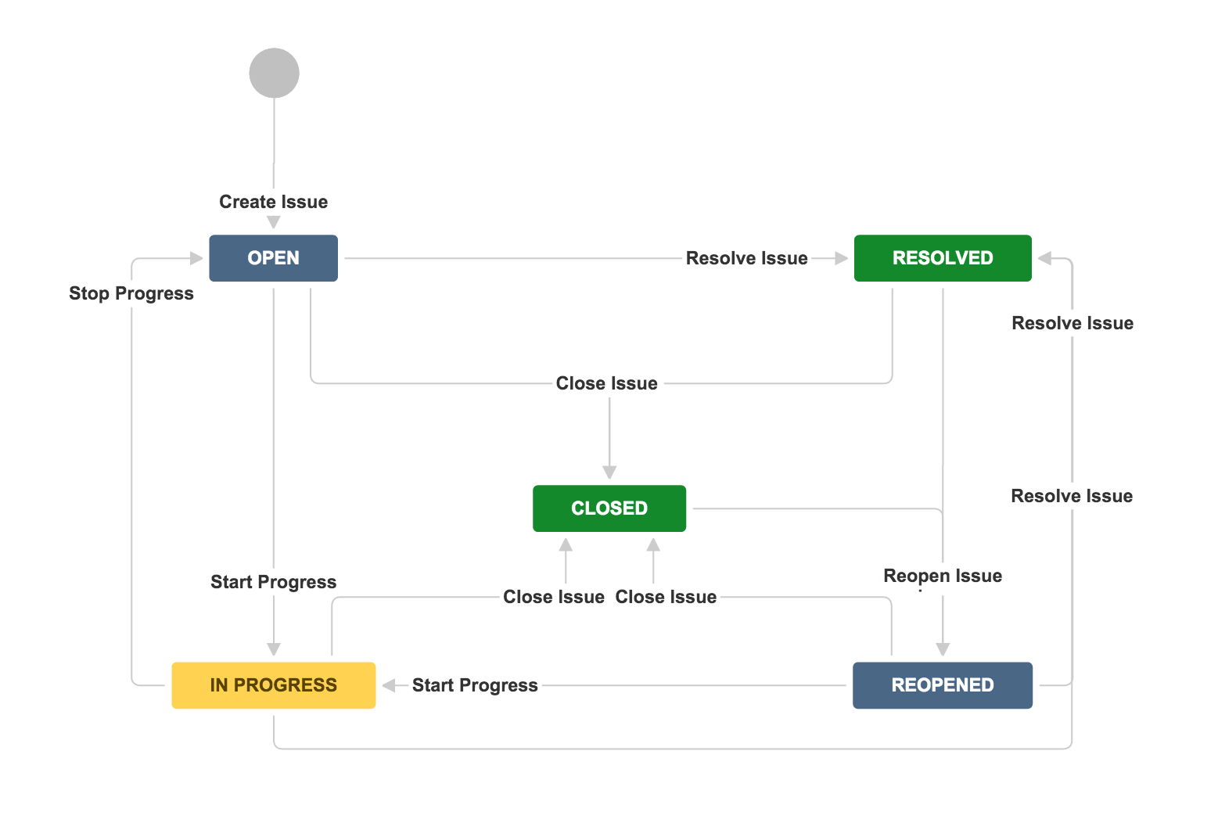

**JIRA CORE Values:**

* Be the change youseek
* Build with heart and balance
* Open Company
* Play as a Team

**Boards:**

In JIRA there are two types of boards which it will be used:

1. Kanban Board (Sprint, Backlog)
2. Scrum Board (Active, Backlog)

Kanban Board: A Kanban board is one of the tools that can be used to implement Kanban to manage work at a personal or organizational level. Kanban boards visually depict work at various stages of a process using cards to represent work items and columns to represent each stage of the process.

Scrum Board: A Scrum board is the face of your process, a visual status of your sprint, showing your work split across different stages of your workflow. ... Scrum and Kanban are popular frameworks for implementing agile practices in teams. Scrum is an iterative framework used to break down complex problems into smaller chunks.

**Why JIRA?**

JIRA is preferred because

1. Transparency
2. Simplicity
3. Core values
4. Unity
5. Adaptabilty

**How to get started with JIRA?**

Step-1: Create a Project

Step-2: Select the type of Product we want to build

Step-3: Name the Project

Step-4: Choose the Board

**Agile Methodology:**

JIRA is works on the agile methodology, this means any where in the phase of building the project we can modify as many time we want.

* Build
* Plan
* Develop
* Test
* Deploy
* Maintain

**Demonstration of JIRA:**

**CREATING A PROJECT**

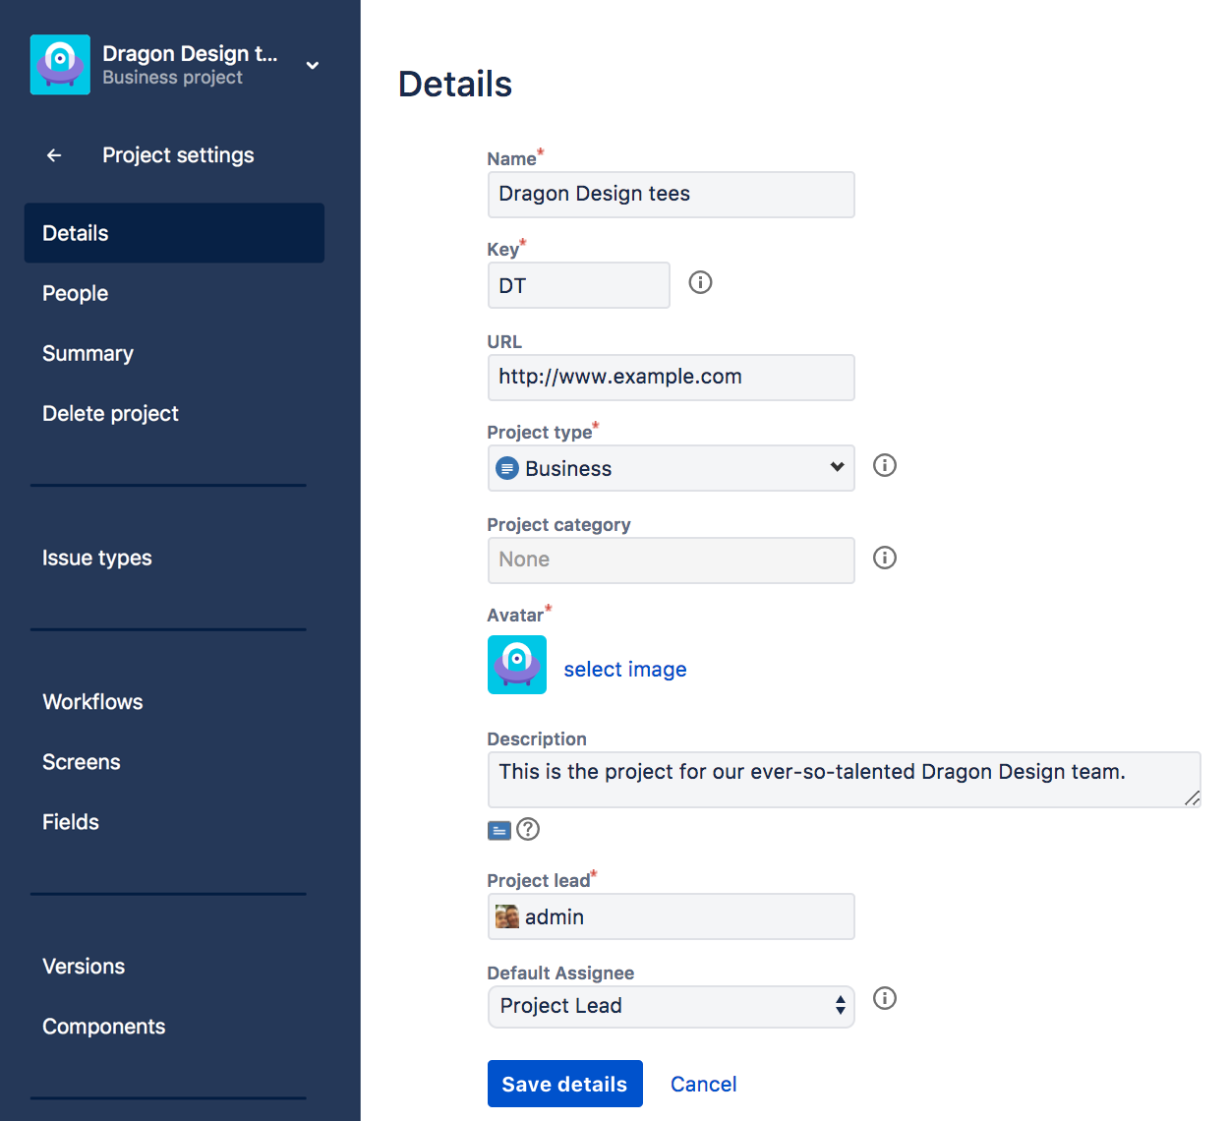

**JIRA BOARD INTERFACE**

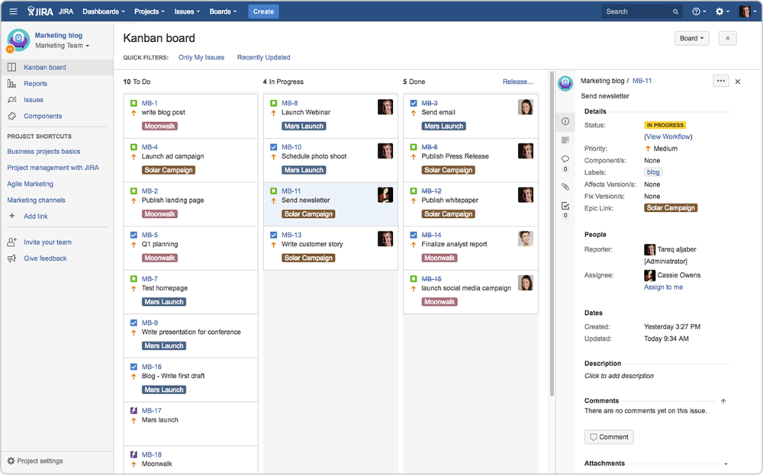

**CREATE A TASK**

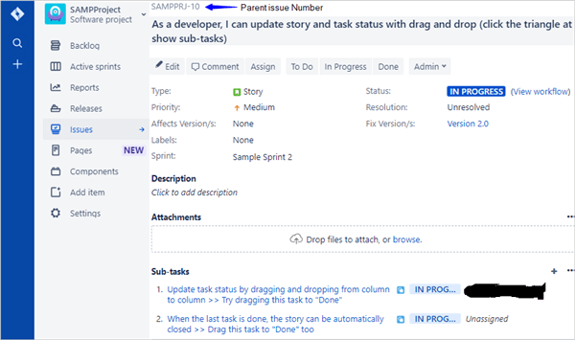

**JIRA BACKLOG**

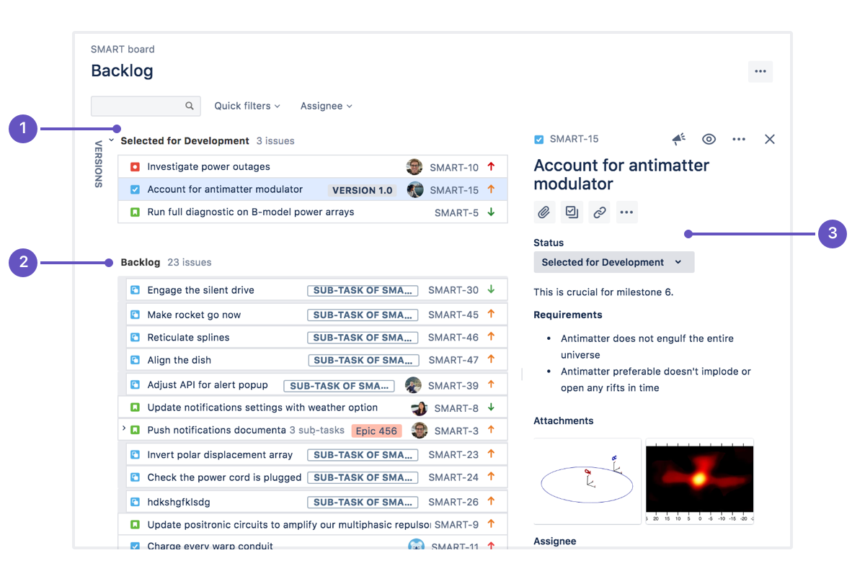

**JIRA RELEASES**

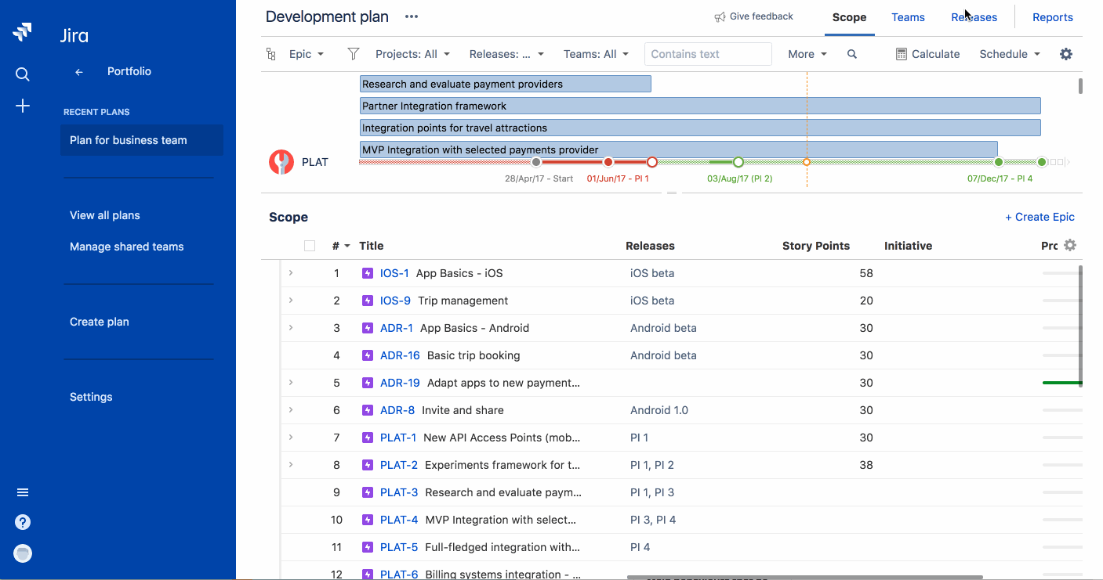

**JIRA ISSUES & TICKETING**

